**ROBOMANIPAL TASK 4 ELECTRONICS**

**By: Rutuj Nagarkar**

OR Gate using switch

<https://www.tinkercad.com/things/knqZrgC7TBd-orswitch?sharecode=csIaEJ3NzmcRshxKbwF25O9jxu88nmyT9akvTeVedLs>

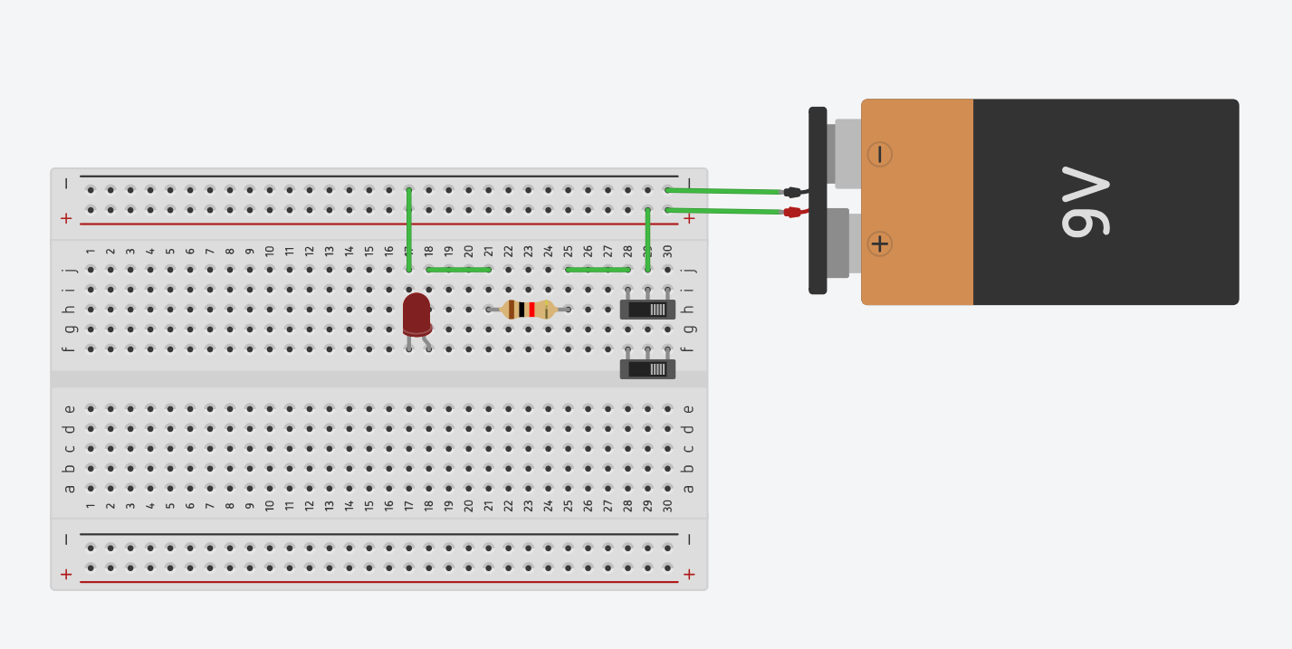

OR Gate using diode

<https://www.tinkercad.com/things/iirCnIm7n9q-ordiode?sharecode=G2TvKD_7cG_c6oLU2ryJvRUTO5k4BvYyelEwhaslT7k>

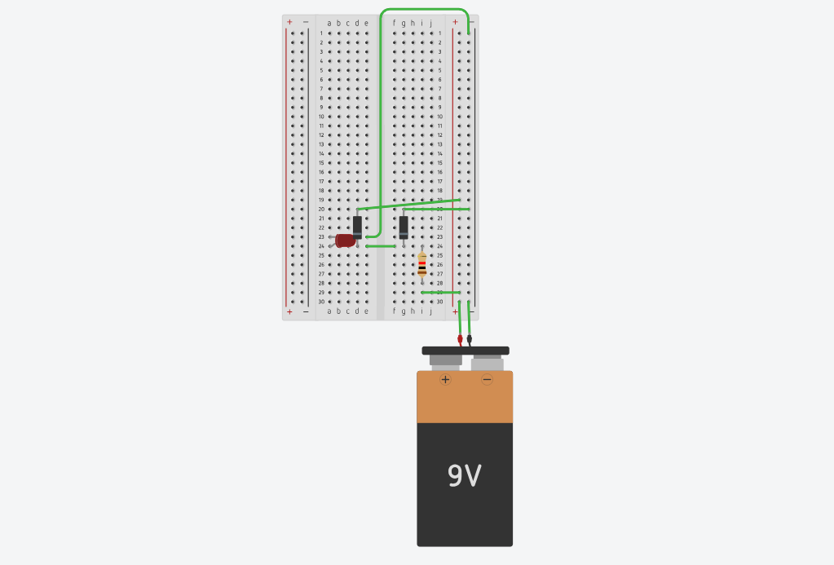

AND Gate using switch

<https://www.tinkercad.com/things/7gktuSnanQQ-andswitch?sharecode=92FmT_ZuOaPPRH6uPiHPiJlC66ovEE4JNGElfphXUak>

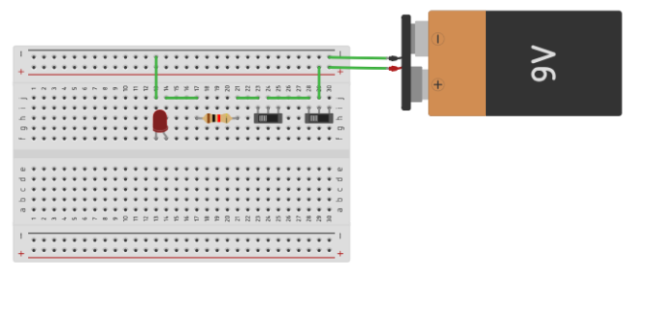

AND Gate using diode

<https://www.tinkercad.com/things/5yBTY7jTiih-anddiode?sharecode=gWBcXxr-9ZH0FYPCZ4tKpA7QtOPTTmoffxNhTlgSCjY>

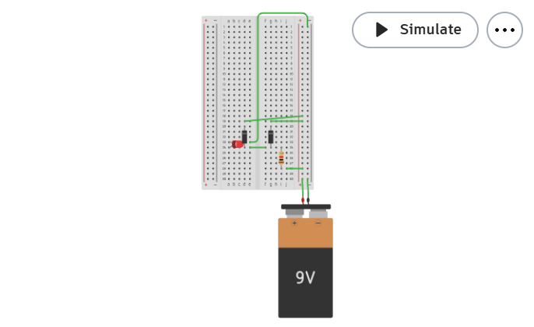

NOT gate using switch

<https://www.tinkercad.com/things/3ENNb2BPyBG-notswitch?sharecode=q9OX2tu_zDb5-5VMGQHB_yWABjyJ5pOS7rWXwu-R6Q4>

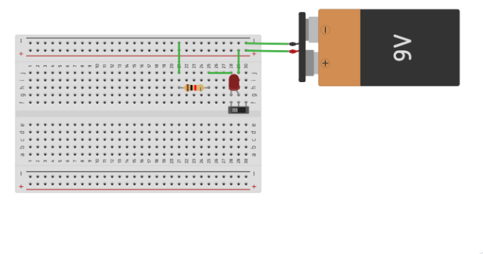

Traffic Signal System - Arduino

<https://www.tinkercad.com/things/5ysZoUV61vr-trafficlightsignal?sharecode=Tz_Bh_xrtTyOJDq5twIZxJP4peZEOFSdEKToyo_K1rs>

